Using Insertion and Deletion Events for Improving Multiple Sequence Alignments and Building the Corresponding Evolutionary Tree

Chantal Korostensky, Ulrike Stege and Gaston Gonnet

Institute for Scientific Computing, ETH Zürich, Switzerland

Abstract
Usually practical algorithms for constructing MSAs fail to produce an exact solution due to the complexity of the problems for the underlying model. The main problem in the biological point of view is the misplacement of gaps.
- Introduction
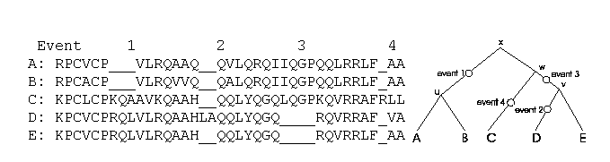
Indel events are shown in the evolutionary tree (right) of the MSA (left).
- Classification of the problem
- Shifted gaps: gap blocks of same size appear shifted horizontally
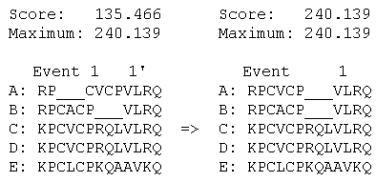
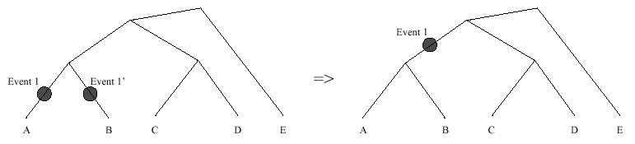
- Split gaps: gap blocks are cut apart vertically and appear as two gap blocks
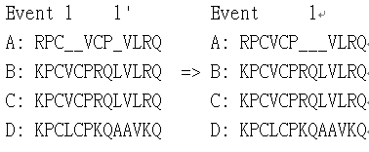
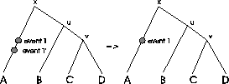
- Split and shifted gaps
